**SOFTWARE REQUIREMENT SPECIFICATION (SRS) DOCUMENT**

|  |  |
| --- | --- |
| **PLACEMENT TRAINING ON FULL STACK DEVELOPMENT** | |
| **STUDENT NAME :** | CHANDRIKA M |
| **SEAT NUMBER :** | 97 |
| **PROJECT ID :** | 17 |
| **PROJECT TITLE :** | Infra - Mess groceries stock maintenance |

**TECHNICAL COMPONENTS :**

|  |  |
| --- | --- |
| **Components** | **Tech Stack** |
| Frontend | Angular |
| Backend | Express JS and Node JS |
| Database | MongoDB |
| API’S | RESTful API’s |

**IMPLEMENTATION TIMELINE :**

|  |  |  |  |
| --- | --- | --- | --- |
| **Phase** | **Deadline** | **Status** | **Notes** |
| Stage 1 | 05/05/2024 |  | Planning and Requirement Gathering |
| Stage 2 |  |  | Desing and Prototyping |
| Stage 3 |  |  | Database Design |
| Stage 4 |  |  | Backend Implementation |
| Stage 5 |  |  | Testing and Implementation |

**TABLE ON CONTENT**

|  |  |
| --- | --- |
|  | **SECTION 1: INTRODUCTION** |
| 1) | PROBLEM STATEMENT |
| 2) | KEY PROBLEMS |
| 3) | STAKE HOLDER’S OBJECTIVES |
|  | **SECTION 2: OVERALL DESCRIPTION** |
| 4) | PURPOSE |
| 5) | PROJECT SCOPE |
| 6) | DEPENDENCIES |
|  | **SECTION 3: USER CLASSIFICATION AND FUNCTIONALITIES** |
| 7) | USER CLASSES AND CHARACTERISTICS |
| 8) | USER PERSONAS |
| 9) | USER STORIES |
|  | **SECTION 4: DETAILED PRODUCT FEATURES** |
| 10) | PRODUCT FEATURES |
| 11) | PRODUCT ARCHITECTURE |
|  | **SECTION 5: OVERALL WORKFLOW** |
| 12) | WORKFLOW DIRAGRAM |

**1. PROBLEM STATEMENT:**

Maintaining optimal levels of groceries in campus messes presents several challenges, including inefficient inventory management, communication breakdowns, tracking stock usage, and ensuring timely replenishment. These obstacles hinder productivity and effective stock maintenance, necessitating a comprehensive solution to streamline processes and enhance operations.

**2. KEY PROBLEMS:**

* Inefficiency: Paperwork, manual calculations, and potential delays can slow down the entire process.
* Errors: Human error can lead to mistakes in ordering, tracking inventory, or managing bills.
* Lack of Transparency: Difficulty in tracking the flow of groceries and expenditure.
* Wastage: Difficulty in monitoring consumption and expiry dates can lead to wasted food.

**3. STAKEHOLDERS' OBJECTIVES:**

1.Supervisor's Stock Oversight: Supervisors require detailed insights into groceries stock for efficient management. Accessible data on levels, orders, and consumption minimizes waste and streamlines replenishment.

2.Efficient Data Input: Stakeholders prioritize a user-friendly system for seamless data entry across indent, order, receipt, and consumption fields, ensuring accuracy and effectiveness in management.

3.Daily Activity Logging and Reporting: Logging daily activities and generating reports are crucial for monitoring, evaluating efficiency, and ensuring accountability, optimizing stocks, and enhancing overall operations.

**4. PURPOSE:**

The Groceries Stock Management Portal streamlines the process of managing groceries stock efficiently. It enables indent entry, approval workflows, and order placement. The portal ensures accurate recording of received groceries with billing details and sub-store wise issuance. It tracks consumption, monitors expiry, and generates reports for maintenance, including monthly reports and cost analysis. This initiative aims to modernize groceries stock management practices on campus.

**5. PROJECT SCOPE:**

The project scope involves developing a portal for groceries stock management in campus messes. It includes functionalities such as indent raise entry, approval workflows, order generation, receipt recording with bill details, sub-store wise issuance, consumption tracking per mess and session, expiry product monitoring, and various reports generation including monthly reports, cost analysis, and comparison rate charts. This aims to optimize groceries management, enhance transparency, and ensure efficient stock maintenance.

Top of Form

**6. USER CLASSES AND CHARACTERISTICS:**

The Groceries Stock Management Portal caters to distinct user classes:

1.Administrators: They possess moderate to high technical proficiency, overseeing system functionality and monitor consumption in each mess and session.

2.Mess Staff: Engaged extensively, they handle tasks like indent entry.

3.Guest Users: With basic technical skills, they have limited access, enabling essential functions and restricted information viewing.

Top of Form

**7. USER PERSONAS:**

The Groceries Stock Management Portal serves the following user personas:

1.Administrators: Oversee system implementation, stock maintenance operations, and utilize reports for decision-making.

2.Mess Staff: Manage daily mess operations, raise indents, and update session wise consumption to minimize wastage.

3.Guest Users: Limited access for viewing public information and basic functionalities within the portal.

Top of Form

**8.USER STORIES:**

**Administrators**: I oversee the groceries stock management portal's implementation, ensuring seamless integration of features like indent entry, order approval, and receipt recording, monitor consumption in each mess and session.

**Mess Staff**: I efficiently handle indents, raise orders list to the Administrators.

**Managemen**t: I depend on accurate reports for informed decision-making in budget planning and stock maintenance.

**9. DEPENDENCIES:**

1.External APIs Integration: Third-party APIs for authentication and billing details retrieval ensure seamless operation.

2.Accurate Data Sources: Reliable data sources maintain accurate stock, order, consumption, and expiry information.

3.Development Tools: Tailored tools aid in efficient portal development for features like indent raising and reporting.

4.Regulatory Compliance: Adherence to regulations ensures legal compliance in billing, inventory management, and reporting.

.

**10. PRODUCT FEATURES:**

**1.Stock Inventory Management**: Efficiently manage groceries stock inventory from indent raising to approval, order generation, and billing details recording.

**2.Sub-store Allocation**: Allocate groceries to sub-stores for balanced distribution across campus messes.

**3.Consumption Tracking**: Monitor groceries consumption in real-time per mess and session to facilitate timely restocking and waste reduction.

**4.Expiry Monitoring**: Track groceries expiry dates to prevent wastage and ensure freshness.

**5.Reporting and Analysis**: Generate various reports, including monthly reports, cost analysis, and comparison rate charts, with customizable dashboards for effective monitoring and decision-making.

Top of Form

**11. APPLICATION ARCHITECTURE:**

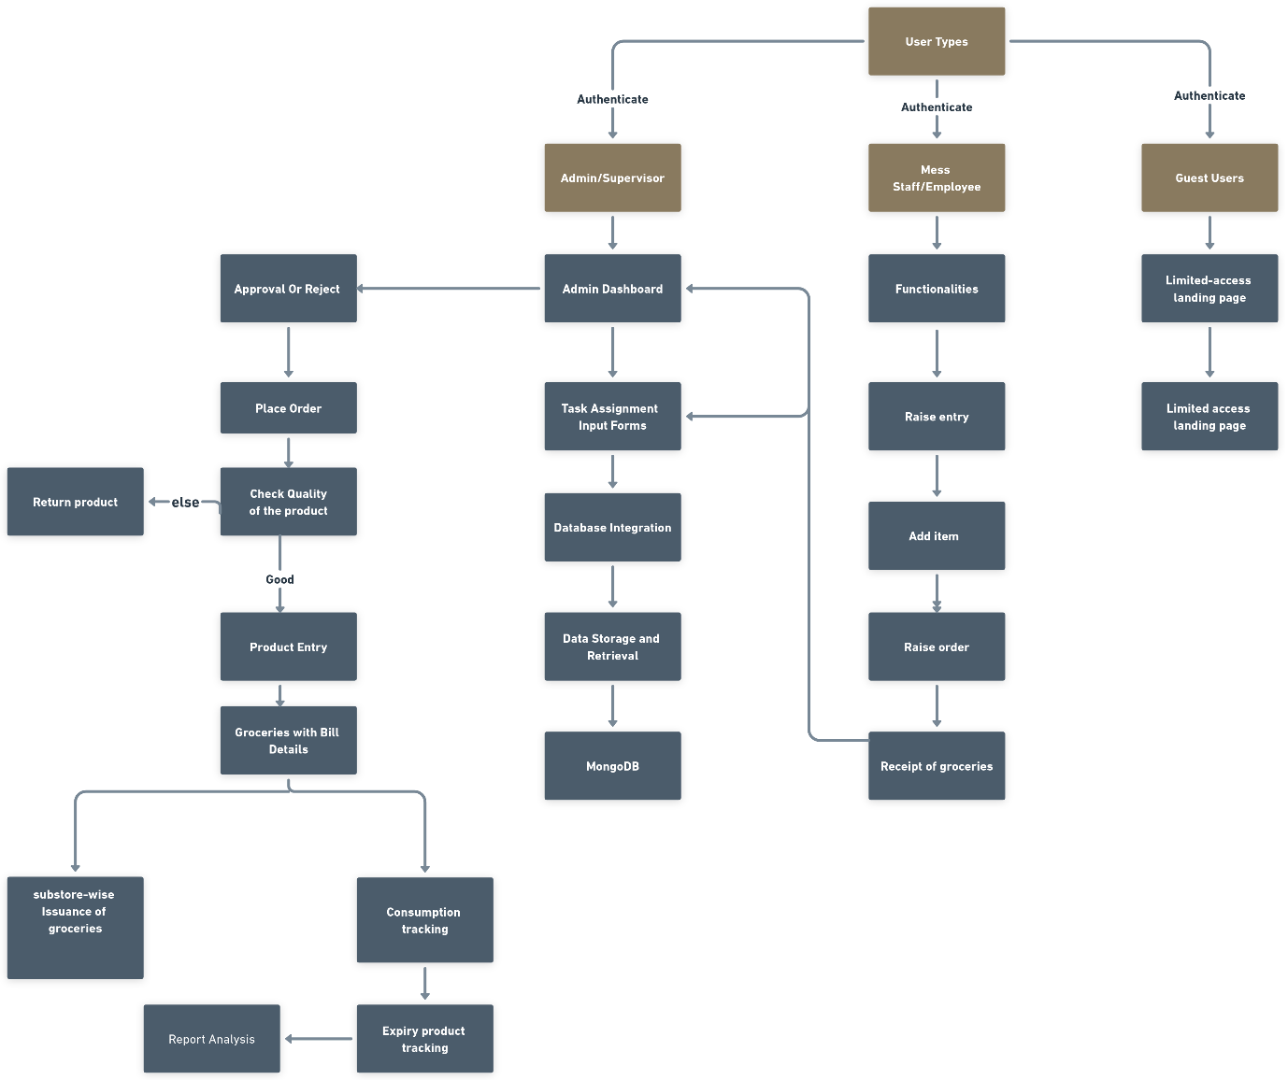

**12. WORKFLOW FOR THE PROJECT:**

